**­­­**

Class 7

**Lecture 6**

**Basic Algorithm**

**Sorting Algorithm .**

**Programming**

**&**

**Algorithm**



**Lab Objectives:**

* What is Sorting Algorithm?
* Insertion Sort.
* Merge Sort

**What is Algorithm?**

An algorithm is a step by step method of solving a problem. It is commonly used for data processing, calculation and other related computer and mathematical operations.

In a non-technical approach, we use algorithms in everyday tasks, such as a recipe to bake a cake or a do-it-yourself handbook.

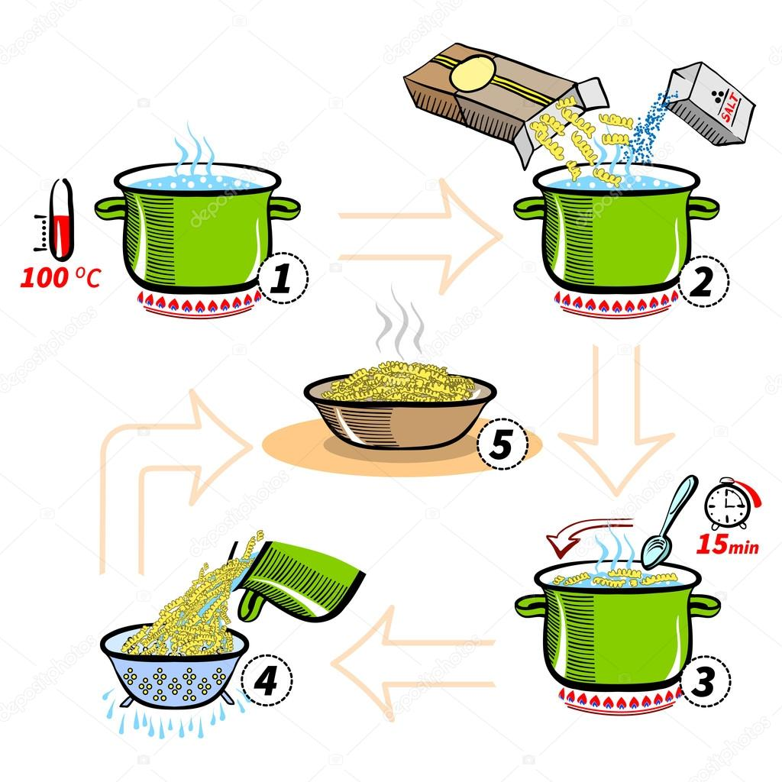

**Sorting Algorithm**

In computer science, a sorting algorithm is an algorithm that puts elements of a list in a certain order.

**Insertion Sort**

Insertion sort is a simple sorting algorithm that works the way we sort playing cards in our hands.

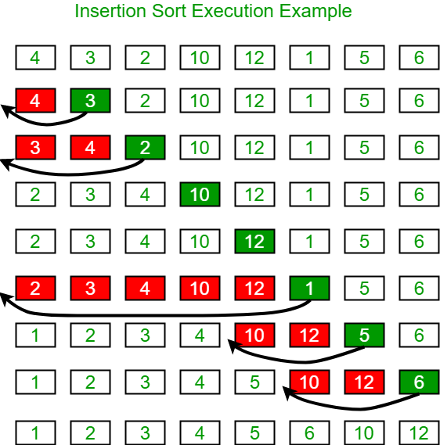

**Merge Sort Algorithm**

Merge Sort is a kind of Divide and Conquer algorithm in computer programming. It is one of the most popular sorting algorithms and a great way to develop confidence in building recursive algorithms.

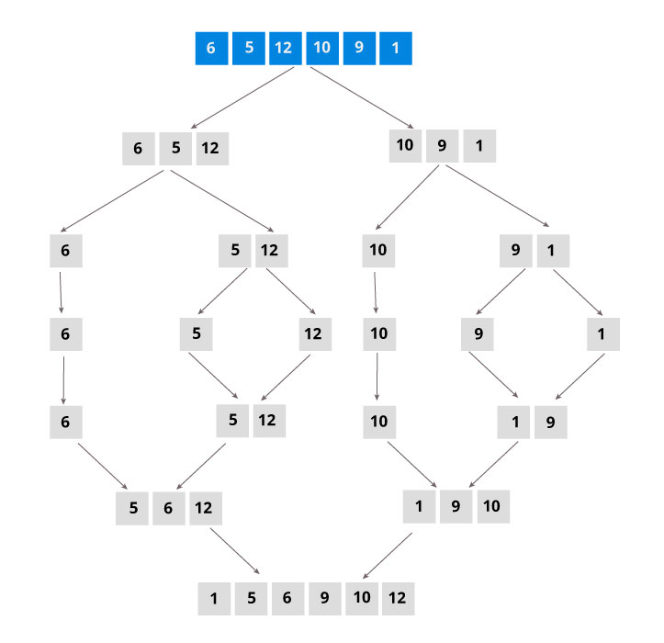

**Divide**

If q is the half-way point between p and r, then we can split the sub array A[p..r] into two arrays A[p..q] and A[q+1, r].

**Conquer**

In the conquer step, we try to sort both the sub arrays A[p..q] and A[q+1, r]. If we haven't yet reached the base case, we again divide both these sub arrays and try to sort them.

**Combine**

When the conquer step reaches the base step and we get two sorted sub arrays A[p..q] and A[q+1, r] for array A[p..r], we combine the results by creating a sorted array A[p..r] from two sorted sub arrays A[p..q] and A[q+1, r].